Planar Ultra-Wideband Absorber Based on TCDA-under-TCDA (Tightly Coupled Dipole Array)

김성중* · 남상욱**
Seongjung Kim* · Sangwook Nam**

* 서울대학교 전기정보공학부
** 서울대학교 전기정보공학부
(sjkim@ael.snu.ac.kr)

ABSTRACT
An ultra-wideband absorber based on TCDA-under-TCDA is proposed. The unit cell of the proposed structure consists of a tightly coupled dipole array (TCDA2) under another TCDA (TCDA1) that is twice the height of TCDA2 (that is, TCDA-under-TCDA structure). Reciprocity is applied to TCDA1 as an absorber when the frequency is out of the operating frequency range of TCDA2. On the other hand, the superstrate (impedance-down transformer) is used for TCDA1 to be an absorber when the frequency is in the operating region of TCDA2 (reciprocity cannot be applied). A –10 dB reflection bandwidth of 0.61 – 6.50 (10.6:1) is achieved with a 0.1 λ_{low} at the lowest operating frequency under normal incidence. The –8 dB bandwidth is moderately reduced to 0.63 – 6.69 (10.6:1) with a 0.1 λ_{low} for the TE mode under 40⁰ oblique incidence and 0.88 – 6.42 (7.3:1) with a 0.15 λ_{low} for the TM mode under 70⁰ oblique incidence.

Key Words : TCDA, ultra-wideband, absorber, low-profile, dual polarization

1. Introduction
With the advancement of radar technologies [1], several methodologies have been proposed to prevent the generation of electromagnetic (EM) waves. One such methodology is the use of an absorber to absorb incident EM waves [2]. For the absorber’s design, a method based on antennas in a two-port network was proposed using the reciprocity theorem [3]. In this method, lossless antennas used as radiating devices can be adopted as absorbers. However, ultra-wideband TCDA, as reported in [4], cannot be directly used as an absorber by means of reciprocity since the loss of the antenna is not negligible (radiation efficiency > 73 %). Therefore, in this study, we proposed the way the antenna-based absorbers can be designed using not only lossless but also lossy antennas.

2. Design of the proposed TCDA-under-TCDA based absorber
For conventional TCDAs, the operating bandwidth is about 4~6:1 [5]. Therefore, the operating bandwidth of TCDA absorber by reciprocity is also limited to that. In the case of TCDA, which is twice as high as the others, half of lowest operating band can be obtained but middle and higher band may be lost. In our scheme, as shown in Fig. 1, we design
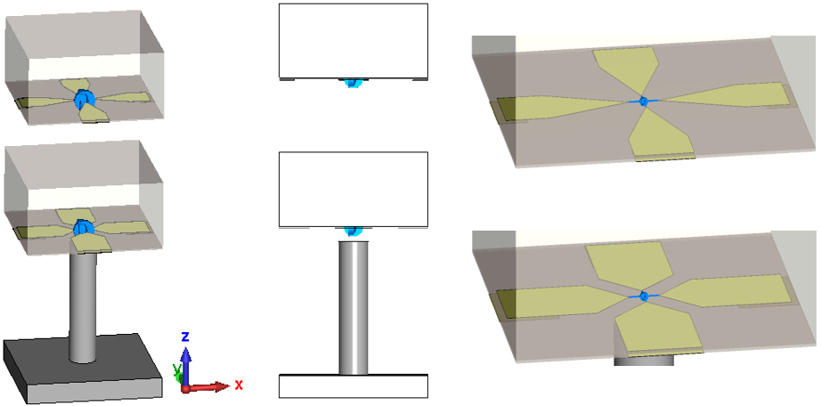
Fig. 1. Perspective, side, each layers view of the unit cell structure. Dielectric superstrates with 2.2 relative dielectric constant are employed. The blue arrows indicate lumped resistors. For the TCDA1 and 2, corresponding resistances are 250 Ω and 150 Ω, respectively. The cylinder aluminum at the bottom side is vertical metal strip (VMS) for insensitive to the oblique incidence plane waves [6].

the absorber composed of TCDA1 (top position) and TCDA2 (bottom position) which are operating at the extremely low, and middle and high frequency band, respectively. At the band TCDA1 operates, TCDA2 is almost open structure and not affects on the TCDA1. Thus, the entire structure becomes an absorber by reciprocity. At the band TCDA2 operates, TCDA2 becomes an absorber itself. Therefore, the entire structure becomes equivalent to that the TCDA1 is in the free space. The
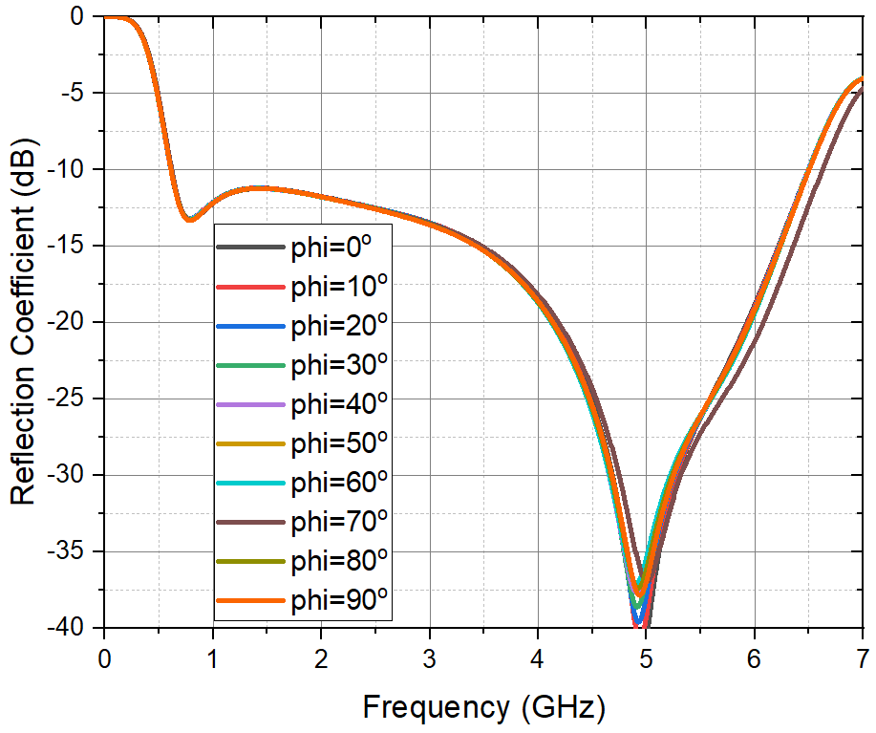
Fig. 2. Polarization independency of the incidence wave.

dielectric superstrate of the TCDA1 makes the incidence plane wave not be reflected at the top side in that situation. Thus, in this way, the entire structure becomes an absorber and the entire structure produces a –10 dB reflection bandwidth of 0.61 – 6.50 (10.6:1) with a 0.1 λ_{low} at the lowest operating frequency under normal incidence. Fig. 2 shows the operating bandwidth and polarization independency.

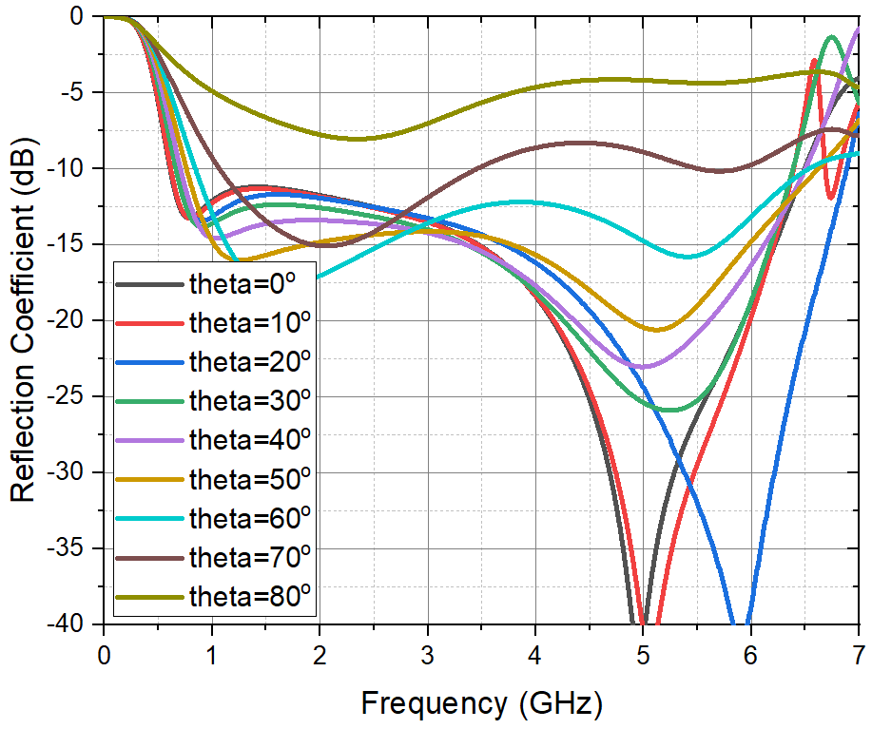
Fig. 3. Responses to TM plane wave with various incidence angles.

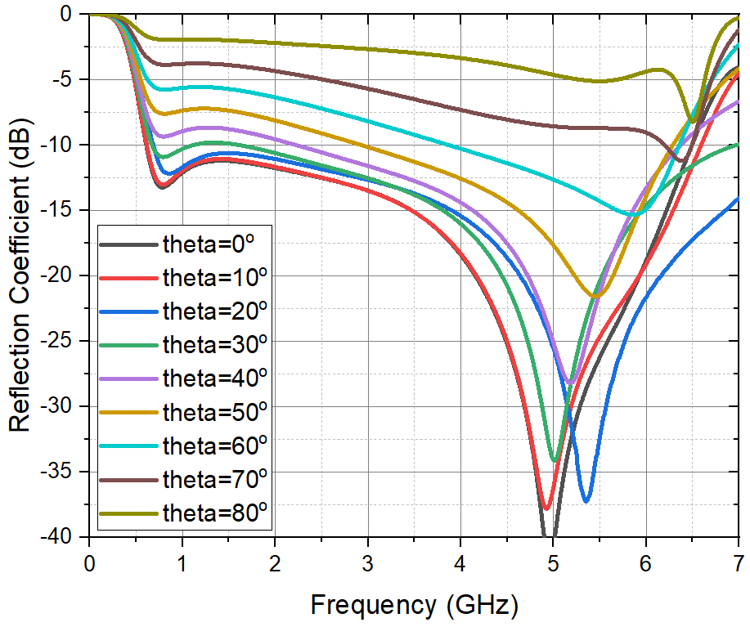
Fig. 4. Responses to TE plane wave with various incidence angles.

Fig. 3 and 4 show the response to TM and TE plane wave with various incidence angles, respectively. For the TM and TE cases, the responses are acceptable under 70° and 40°, respectively.

3. Conclusion
We proposed the absorber composed of TCDA-under-TCDA. Compared with conventional TCDAs, the operating bandwidth as an absorber is incredibly increased to 10.6:1. It is worth noting that owing to our work, the antenna-based absorbers can be designed using both lossless and lossy antennas; this technique provides added flexibility in the design of antenna-based absorbers.

References
[1] Bekkerman, Ilya, and Joseph Tabrikian. “Target detection and localization using MIMO radars and sonars.” IEEE Transactions on Signal Processing 54.10 (2006): 3873-3883.
[2] Chen, Jianlin, Yuping Shang, and Cheng Liao. “Double-layer circuit analog absorbers based on resistor-loaded square-loop arrays.” IEEE Antennas and Wireless Propagation Letters 17.4 (2018): 591-595.
[3] Wu, Changying, S. Lu, Z. Yang, and Y. Yashchyshyn. “A UWB absorber based on the TCA concept in the UHF band.” IEEE Transactions on Antennas and Propagation 68.5 (2019): 4132-4136.
[4] Moulder, William F., Kubilay Sertel, and John L. Volakis. “Superstrate-enhanced ultrawideband tightly coupled array with resistive FSS.” IEEE Transactions on Antennas and Propagation 60.9 (2012): 4166-4172.
[5] Munk, B. A. Finite antenna arrays and FSS. John Wiley & Sons, 2003.
[6] Kim, Seongjung, and Sangwook Nam. “Bandwidth extension of dual-polarized 1-D TCDA antenna using VMS.” IEEE Transactions on Antennas and Propagation 67.8 (2019): 5305-5312.

